INDIVIDUAL ACCOUNT

TRUST ACCOUNT

KIDISTAR ACCOUNT

EXECUTORS ACCOUNT

ADMINISTRATORS ACCOUNT

CLIENT ACCOUNT

OTHER,

*Specify*

Account Name

Account No.

Personal Banker

Customer ID

Date

D

D

M

M

Y

Y

Y

Y

# Requirements

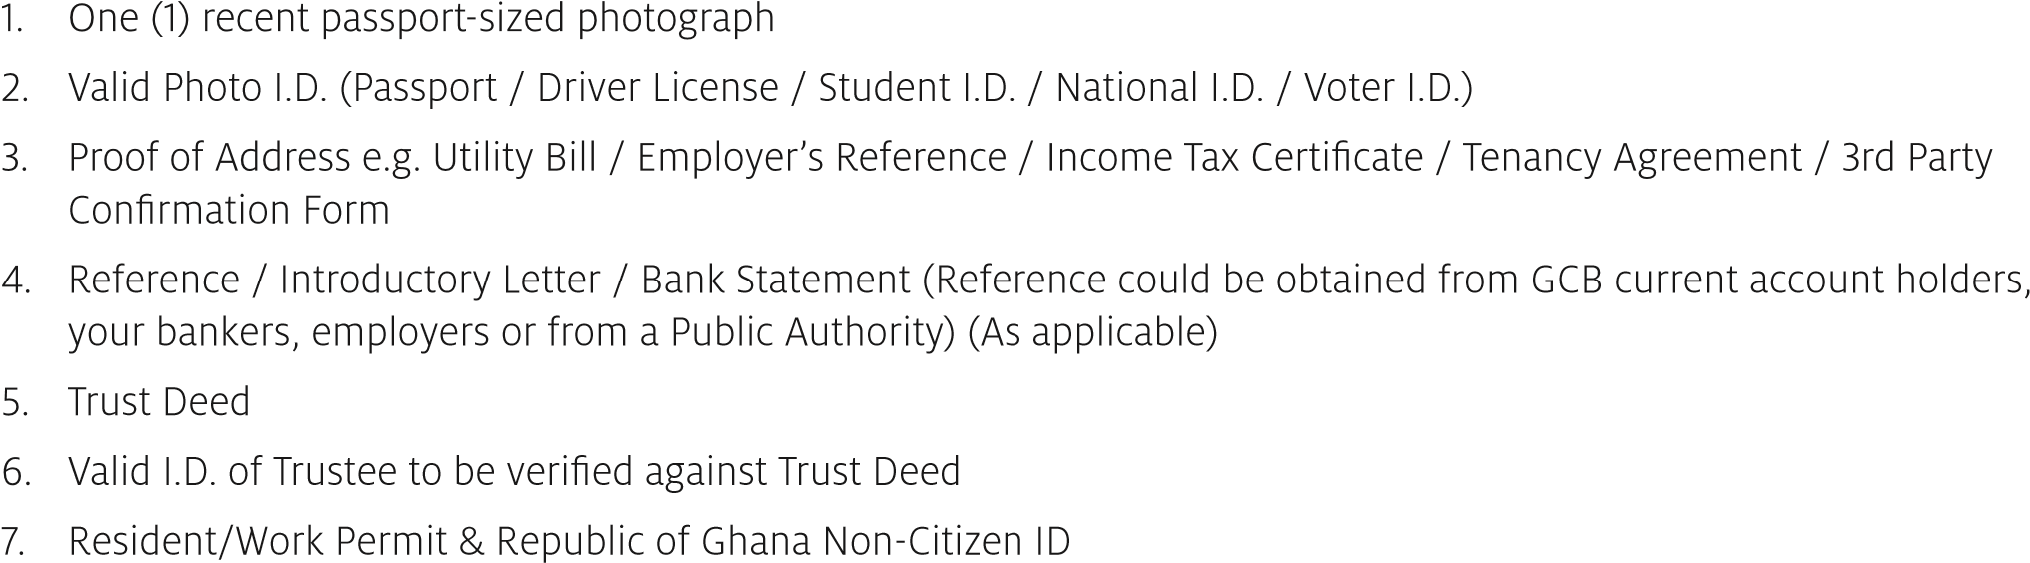

**Terms And Conditions for GCB Bank Ltd.**

**Current And Savings Accounts For Individual Account / Joint Account / Trust Account / Executors Account / Administrators Account / Client Account, Etc.**

Please read this page carefully. It provides you (The Customer(s) with important information about GCB Bank Ltd (GCB) Current and Savings Accounts.

## The Bank

The information on this page (and any further instructions and conditions that may be prescribed by the Bank from time to time) are the terms of the agreement between you and GCB. When you sign the Account Opening Form you accept these terms as binding on you.

The hours of business will be advertised from time to time.

You assume full responsibility for the genuineness, correctness and validity of all endorsements appearing on all cheques, orders, bills, notes, negotiable instruments and receipts or others deposited in the account.

The account may be debited for any service charge that is set by the Bank from time to time.

All notices or letters will be sent to the address supplied by you and will be considered duly delivered and received at the time it is posted. Notices in the press will be deemed sufficient for this purpose.

The Bank will not be liable for funds handed over to any person other than the Bank’s Cashier/Teller for the credit of your account. Any anomaly in the entries on your Bank statement must be

thereof and you agree that failure to give such notice absolves the Bank from all liabilities arising there from. The Bank may exercise its general lien or any similar right it is entitled to by or consolidate all or any of my accounts with any liabilities to the Bank and set off or transfer any sum or sums standing to the credit of anyone or more of such accounts or any other credit.

## E-Alert / SMS Alerts

Where requested, the Bank may provide e-Alert / SMS Alerts or other similar service to provide information on transactions. The service is provided ‘As Available’ and without any warranty of fitness for a specific purpose. The Bank does not warrant that this service will always be uninterrupted, or that any information provided is accurate and current as at the time it is received. The Bank disclaims responsibility for any defect, corruption, virus or related problems attributed to your telecom equipment or the service provided by any network provider.

## Savings Account

Request to open a Savings Account will be granted on proper completion of the Bank’s Account Opening Form Deposits will be received up to any amount.

One account only may be opened for any one person either in his own name or jointly with another or others. Depositors should note that the Form of Application includes a certification that the applicant has no Savings Account at any of the other branches of GCB Bank Ltd.

Money may be deposited in the joint names of two or more persons to be payable to both, or all of them, or to any one or more of them, or to the survivor(s).

Collection and clearance of cheques, drafts, dividend warrants and other instruments on Savings Accounts can only be allowed at the discretion of the Branch Manager.

Interest will be calculated on the balance on account set by the Bank from time to time and applied on monthly basis.

Except by special arrangement with the Bank, deposits can be withdrawn only during business hours. Cheques may not be drawn by depositors on Savings account.

In the event of the Savings Withdrawal booklet being lost or spoilt the Bank may on receiving a satisfactory explanation, and indemnity, issue a new Savings Withdrawal booklet

The Bank reserves to itself the right to alter or add to these rules at any time and to alter the rate of interest allowed from time to time.

## Cheques

All cheques or orders signed by you (or either or both or all of you if a joint account according to mandate) will be honoured by the Bank and your account will be debited for such cheques or orders whether such account be for the time being in credit or overdrawn or may become over--drawn in consequence of such debit.

The Bank is under no obligation to honour any cheque drawn on your account unless there are sufficient funds in the account to cover the value of the said cheques and such cheques may be returned to you unpaid.

The Bank may exercise its discretion in allowing withdrawals against uncleared cheque(s). Where the cheques are returned unpaid thereafter the Bank shall have the right to hold on to the returned cheque and take further action it deems appropriate to recover the value of the cheque from you. The Bank shall have the right whenever it deems appropriate to confirm the issuance of a cheque drawn on the current account failing which the cheque may be returned with “Drawer’s Confirmation Required” endorsed thereon.

Customer must ensure that their cheque book is kept under lock and key place to prevent unauthorised persons from gaining access to same and neglect of this precaution may be a ground for any consequential loss being charged to your account.

If your cheque book gets lost, missing or stolen you must notify the Bank immediately. The Bank shall not be held liable for any unauthorised use of your cheque book where the loss or otherwise of same has not been notified immediately.

Overdrafts may be available to customers upon arrangement with the Bank. If you do not have such arrangement and your account becomes overdrawn, we may charge you an extra fee and interest at our current rate for unauthorised borrowing. If your account does not have enough cleared funds to cover an amount you want to withdraw we may return your cheque unpaid. The Bank reserves the right to use credit balance on your current account to set off any outstanding exposures on any of your accounts.

## Paying Interest

Customer will be liable for the payment of interest charges at the rate fixed by the Bank from time to time for any sum(s) standing to the debit of the current account. The current account may also be debited for the Bank’s usual banking charges, interest, commissions, etc.

## Termination Of Agreement

Either party may terminate this agreement at any time by notifying the other in writing.

Where customer is terminating the agreement, the termination becomes effective where any cheques and amounts carried on the account have been paid and all cheque books and cards issued to customer are sent back to the Bank. Where the Bank is terminating agreement and the account is overdrawn, customer must pay all sums outstanding on the account otherwise the Bank may take appropriate legal action for recovery.

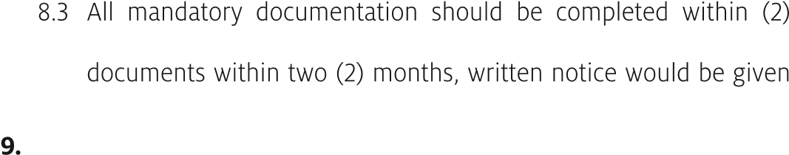months of opening the account. If you do not provide the required

to you after which your account will be automatically closed.

## Joint Holders

In addition to the foregoing, in the case of joint accounts, the following shall apply If one of the holders dies; Any money for the time being standing to the credit of your joint accounts(s) shall be held to the order of the survivor (subject to the applicable legislation). Any liability incurred by joint account holders to the Bank (whether in the form of borrowing or otherwise) shall be joint and several. The joint account holders are jointly liable for the functioning and the balance of the account.

The Bank shall not be liable for any funds / assets deposited by customer which are subsequently found to have been derived from illegal sources or activities. The customer confirms that the funds / assets deposited are not derived from any illegal sources or activities.

## Sharing Of Personal Information

You consent to the Bank making available information concerning your account including personal information to the Central Data Bank of Ghana Association of Bankers and Credit Reference Bureaux and Agencies where necessary.

# GCB Bank Limited

**Individual Account Opening Form** your bank for life

## General Account Information *(Complete in block letters and tick where applicable)*

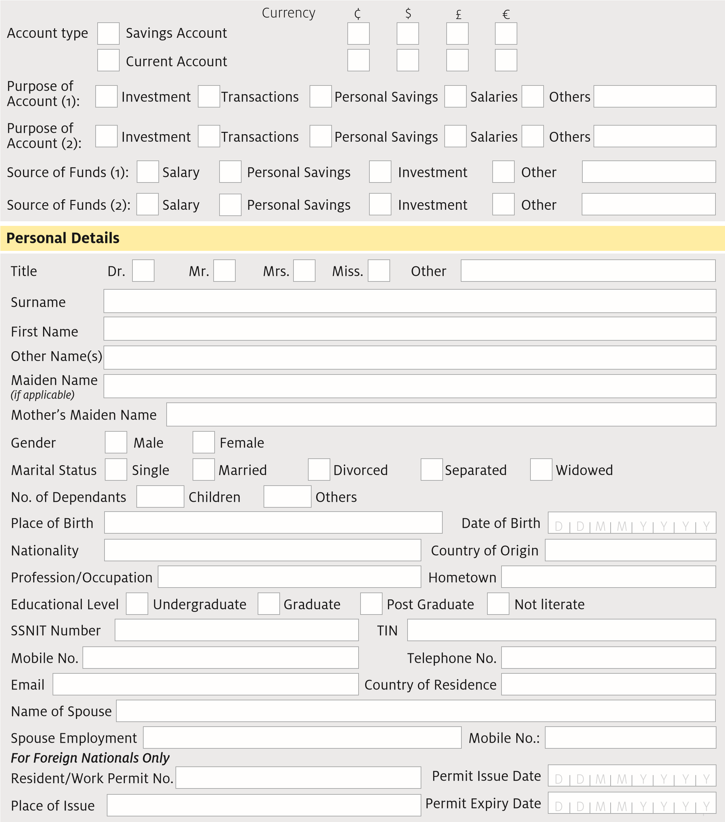

## Valid Means of Identification *(Please tick and provide relevant details)*

Y

National ID

Driver’s Licence

Passport

Voter’s ID

Others

*Specify*

*)*

*(*

Issue Date

Issue Date

Issue Date

Issue Date

Issue Date

Expiry Date

Expiry Date

Expiry Date

Expiry Date

Expiry Date

## Contact Details

**Residential Address Abroad (If Applicable)**

Title to Residence

Outright Ownership

Mortgaged

Lease

Others

*)*

*specify*

*(*

Others

*)*

*specify*

*(*

Rented

Family House

Proof of Address

Proof of Address

Serial Number

Electricity Bill

Telephone Bill

Water Bill

Tenancy Agreement

Postal Address

**Residential/Permanent Address**

Res. Address

Street Name

Issue Date

House No.

Street Name

City/Town

Suburb

Post Code

Country

City/Town

Nearest Landmark

Digital Address/Pincode

Metropolitan, Municipal and District Assembly

|  |
| --- |
| **FATCA/Common Reporting Standard (CRS) Requirement For US/EU Nationals** |
| Tax Identification No. Social Security No. |

## Details of Contact Person *(In case of emergency)*

|  |  |  |  |  |  |  |  |
| --- | --- | --- | --- | --- | --- | --- | --- |
| Name: Mobile No. |  | |  | | | |  |
| Relationship to cont Residential Address: | | act person: |  | Occupation: |  |
|  | | | |
|  |  |  | | | |

**Account Service(s) required *(Please tick applicable option below)***

Card Preference:

ReadyCash Card

mastercard Standard

Prepaid card

mastercard Gold

Other

*specify*

*)*

*(*

VISA Card Classic

Online Purchase:

mastercard Secure Code

Verified by VISA

Electronic Banking Preference:

Internet Banking

Mobile Banking

Transaction Alert Preference:

E-Alert

Email Address

Statement Preference:

Email

Postal

Collection at Branch

SMS Alert

Mobile No.

Cheque/Savings Withdrawal

Book Requisition

Yes

No

2

your bank for life

## Employment Details

Number of Years with

Current Employer:

Mode of Salary payment:

Cash

Cheque

Direct Credit

Wage/Monthly

Salary (GH¢):

Less than 1,000

More than 10,000

1

5,000

,000 -

5

,001 -

10,000

Employer’s Name

Nature of Business

Employer’s Address

Nearest Landmark

Region

City/Town

Office Phone No.

Employer’s Email

Mobile No.

Employed (Public)

Employed (Private)

Unemployed

Student

Self Employed

Retired

Other

*(*

*specify*

*)*

**Employment Status**

## Beneficial Owner(s) Details *(If Applicable)*

Full Name

Relationship to customer

ID Type

Title

Dr.

ID Number

Mobile No.

Date of Birth

Mr.

Mrs.

Miss.

Others

*)*

*Beneficial owner is a person who enjoys the benefit of ownership even though title is in another name*

*(*

House No.

Street Name

Landmark

City/Town

Occupation

Spouse Name

Region

Spouse Address

D

D

M

M

Y

Y

Y

Y

## Expected Account Activity

|  |  |  |  |  |  |  |  |  |  |  |  |  |  |  |  |
| --- | --- | --- | --- | --- | --- | --- | --- | --- | --- | --- | --- | --- | --- | --- | --- |
|  | | | | | | | |  | | | | | | | |
|  | **Transaction Type** | **Expected No. of Transactions Per Month** | | | | | | **Expected Amount Per Month** | | | | | | |  |
| Deposits (Funds inflow)  Account (1)  Account (2) |  | | | | | | 1-10,000 10,001-20,000 20,001 plus  1-10,000 10,001-20,000 20,001 plus | | | | | | |
|  | 1-5 6-10 11 & Above 1-5 6-10 11 & Above | | | | |
|  |
|  |
|  |
| Withdrawals (Funds outflow)  Account (1)  Account (2) |  | | | | | | 1-10,000 10,001-20,000 20,001 plus | | | | | | |
|  | 1-5 6-10 11 - Above | | | | |
|  |
|  | 1-5 |  | 6-10 |  | 11 - Above |  |  | 1-10,000 |  | 10,001-20,000 |  | 20,001 plus |
|  | | | | | | | | | | | | | |

Name of Associated Bus.

*(*

*If Applicable*

*)*

Type of Associated Business

Business Line

Associated Business Address

% Holding

## Account(s) Held with GCB and other banks

|  |  |  |  |  |
| --- | --- | --- | --- | --- |
|  | **Name of Bank & Branch** | **Account Name** | **Account Number** |  |
|  |  |  |
|  |  |  |
|  |  |  |

## Account Opening Mandate

Name

Signature ..................................... Date ...................................

Sole Signatory

Mandate authorization

*(*

*Please tick as appropriate*

*)*

Others

*(*

*Specify*

*)*

**Where Applicant is not Literate OR is Visually Impaired and the Form is Completed by a Third Party**

I agree to abide by the content of this agreement and acknowledge that it has been truly and audibly read over and/or explained to me by a reader/interpreter. The language of interpretation is ……………....................................….

Customer’s Name ........................................................................................................ Signature ............................................

Interpreter’s Name ...................................................................................................... Signature ............................................

Address of Reader/ Interpreter .................................................................................................................................................

Mobile No. ................................................................................................................. Date .....................................................

### Customer's Specimen Signature (Sign three times in the box below )

**SIGNATURE**

**RECENT PASSPORT-SIZED PHOTOGRAPH**

4

## Declaration

I hereby apply for opening of account(s) with GCB Bank Ltd. .................................................... branch. I understand that the information given herein and the documents supplied are the basis for opening such account(s) and I therefore warrant that such information is correct. I have read,understood and agree to be bound by the terms and conditions governing the operation of the account(s). I further undertake to indemnify the Bank for any loss suffered as a result of any false information or error in the information provided. **Disclosure to Credit Reference Bureaux**

The bank will obtain information about you from the Credit Reference Bureau to check your credit status and identity. The bureau will record our enquiries which may be seen by other institutions that make their own credit enquiries about you.

The Bank shall also disclose your credit transaction to Credit Reference Bureaux in accordance with credit reporting ACT, 2007 (ACT 726).

Name ........................................................................................ Signature ..................................... Date ...................................

## FOR BANK USE ONLY

1. **Initial Deposit by** Cash GCB Cheque GCB Draft Transfer Amount .......................................
2. **Authentication For Politically Exposed Persons**

Is the Applicant a Politically Exposed Person (PEP) or associated with PEP ? YES NO

If Customer is closely associated with PEP, state relationship ............................................................................................

Source of wealth (If a PEP or associated with a PEP) ..............................................................................................................

1. **KYC/Risk Profile** Low Risk Medium Risk High Risk
2. **Requirement Checklist**

**Documents Required**

**CHECKED DEFERRED WAIVED N/A**

*( Original IDs/Documents must be seen)*

1. Duly Completed account opening form
2. Specimen Signature Card duly Completed
3. Recent Passport - sized photograph
4. Proof of Identity
5. Resident/Work Permit & Republic of Ghana Non-Citizen ID
6. Proof of Address
7. Confirmation of Mobile phone number
8. Letter from Employer/School (Salary/Student)
9. Copy of Letters of Administration/Trust Deed
10. Evidence of Visit to customer's residence/office

/factory sites (In case of high risk )

1. **Is Customer socially/financially disadvantaged?** YES NO
2. **If Yes, state other Document(s) obtained in line with Bank’s policy on socially/financially disadvantaged customers .**..........................................................................................................................................................................................
3. **Account Opened By :**

Name ..................................................................................... Signature......................................... Date ..............................

1. **Deferral/Waiver Of Document (If Any) Authorized By :**

Name ..................................................................................... Signature......................................... Date .............................

1. **Documents Verification Carried Out By :**

Name ..................................................................................... Signature......................................... Date .............................

Comments .......................................................................................................................................................................................

1. **Account Opening Authorized/Approved By :**

Name ..................................................................................... Signature......................................... Date .............................

1. **For PEP and Other High Risk Customers, Refer to the Managing Director /Head of Business Unit for Approval**
2. Name .................................................................................. Designation ................................................................................

Signature .................................................................................. Date .............................................................................

1. Name .................................................................................. Designation ................................................................................

Signature .................................................................................. Date .............................................................................

6